**Hardware Equipment and Setup**

Our system uses the OLIMEXINO-328 and two SHIELD-EKG-EMG boards to collect sEMG signals from the sensor positions shown in Fig.x. We sample at xxx Hz from four sensors, and use two ground sensors placed behind the neck to reduce interference noise and ambient noise. Experimental results are recorded using SHIELD-EKG-EMG-PRO. Data are processed with a low pass filter at a low frequency of 3.4 kHz to remove the drifts seen.

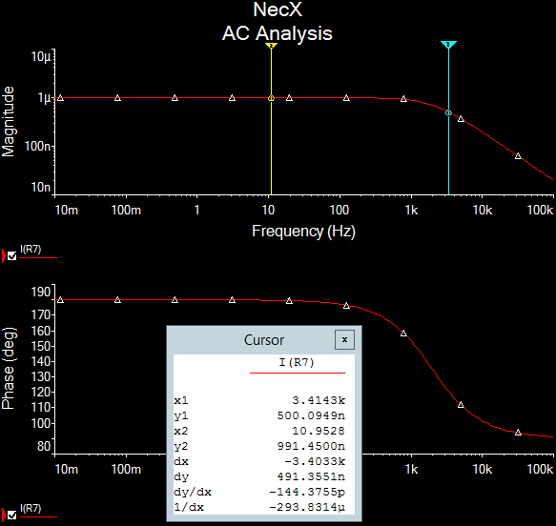

Figure 1. AC analysis for filter system

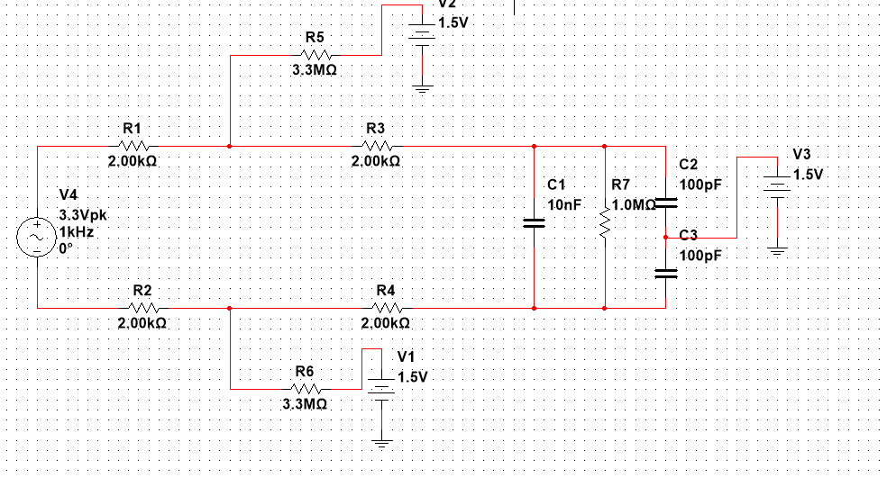

Figure 2. MultiSim for schematic of filter system